DMIT 1530 Flexbox Layout Exercise

The layout shown below can be done using flexbox properties such as display, flex-wrap, justify-content, align-items, & flex-basis.

Download the exercise starter files to begin.

The build:

* Give the main content area a width of 65%, a border of 1px, a border radius of 5px, and pa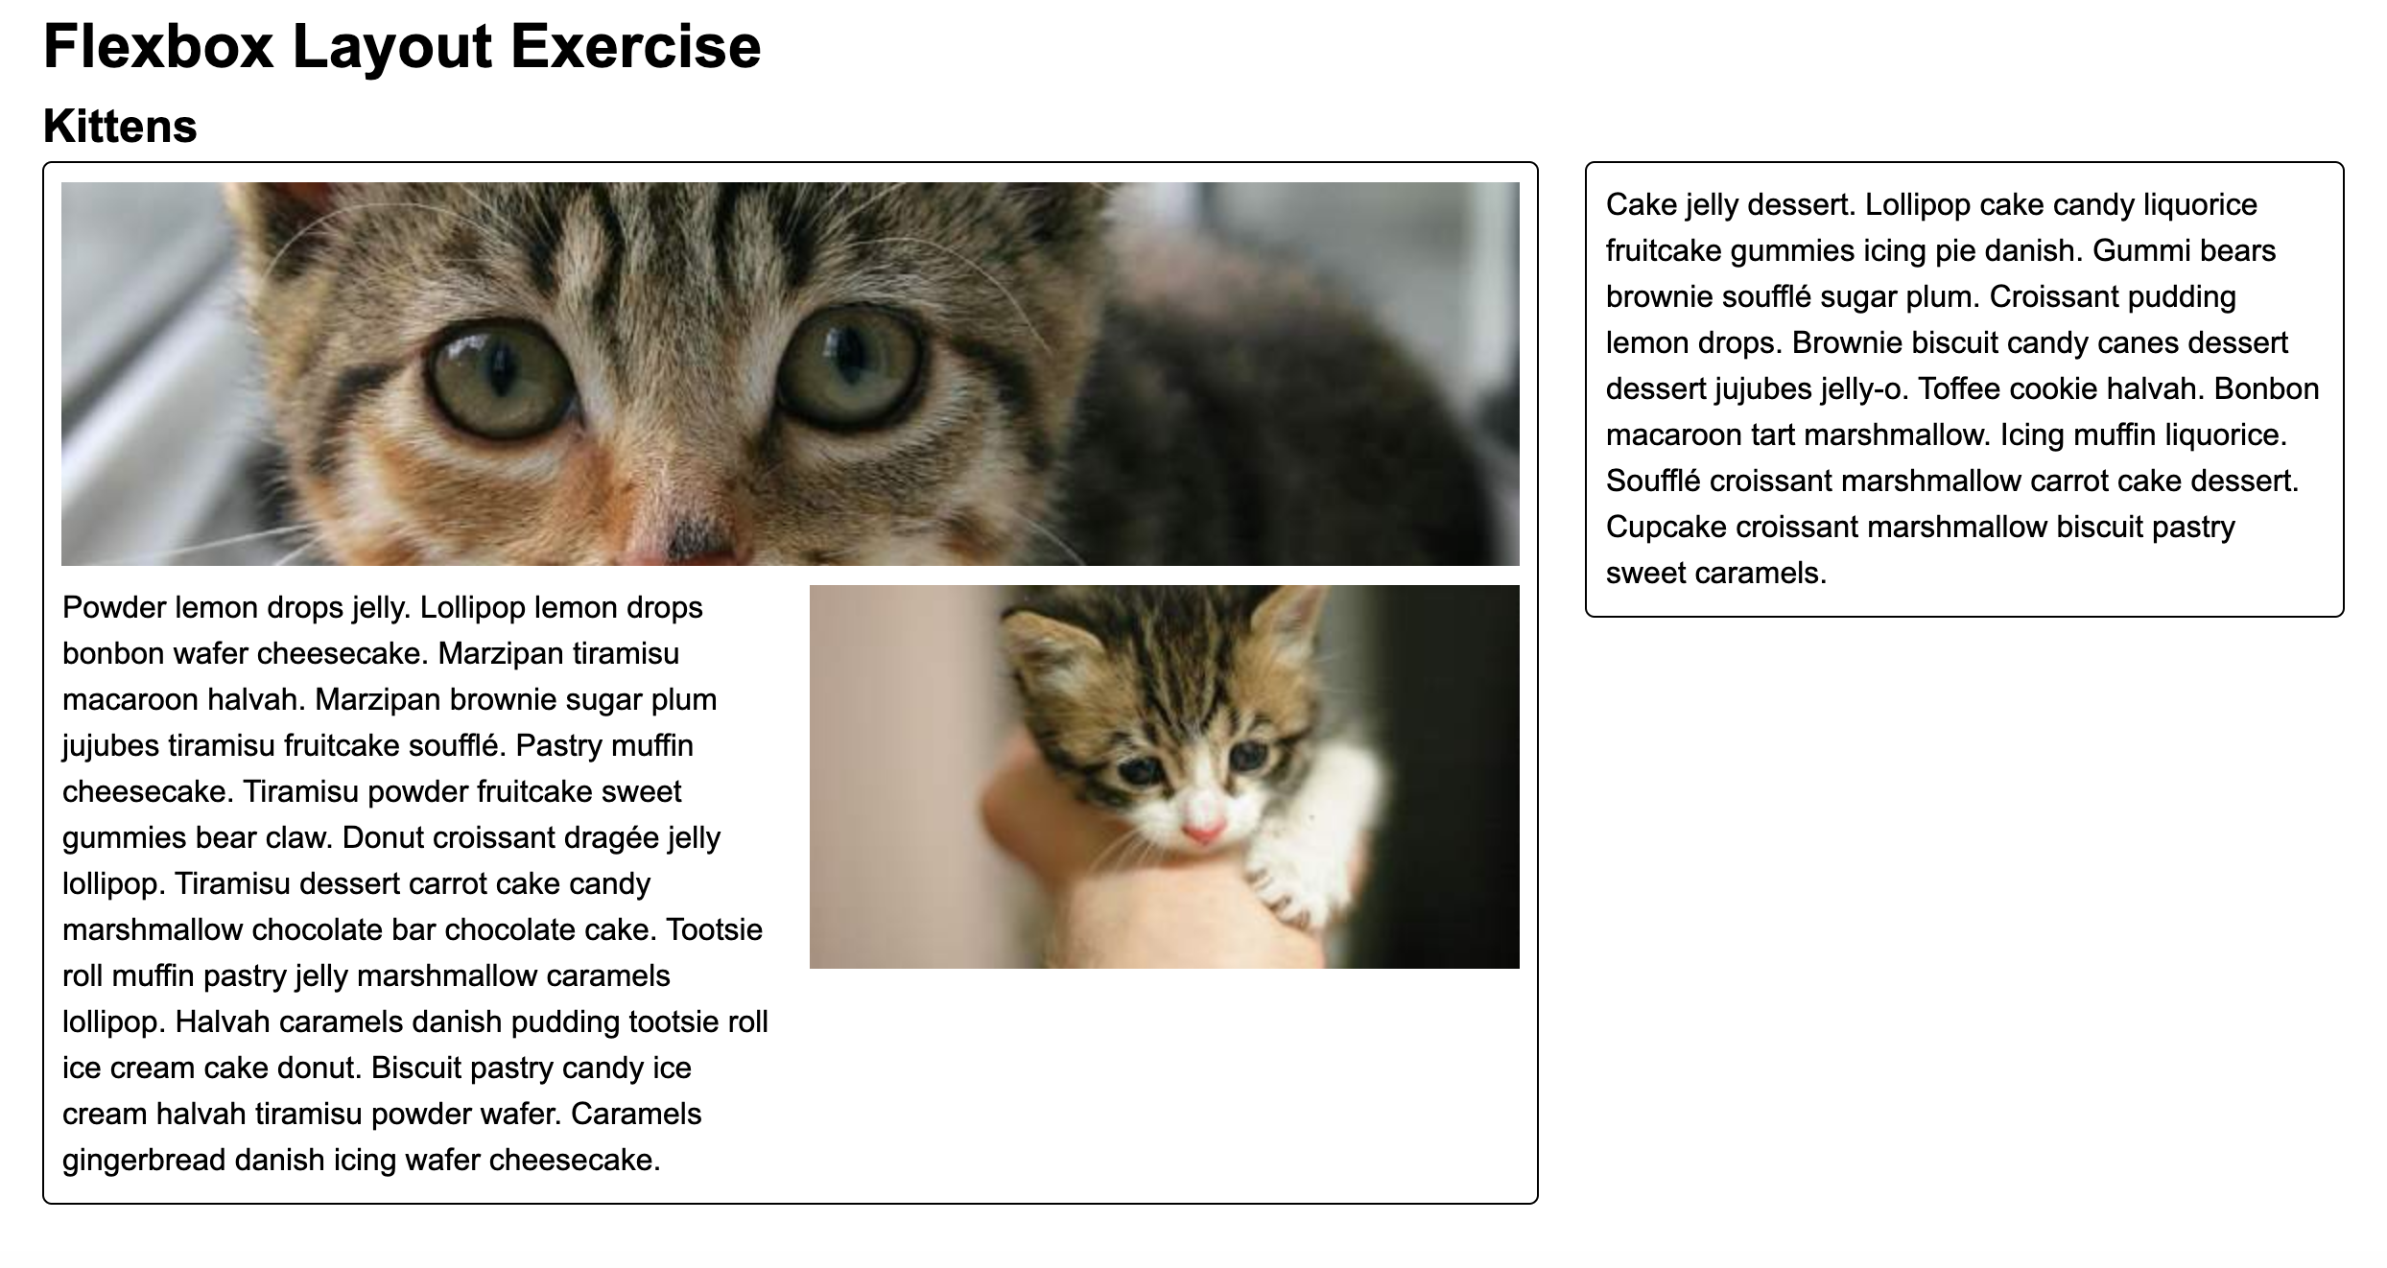dding on the top and bottom of 10px.
* Inside the main content area the paragraph will be a width of 370px.
* Give the aside a width of 33%, a border of 1px, a border radius of 5px, and padding all around of 10px.
* Use your flex box properties to achieve the same layout and positioning of the elements as the screenshot.